WOORE PARISH COUNCIL
VACANCY FOR COUNCILLOR
There is one casual vacancy on the above Council following the resignation of Councillor Andrew Ford.
Following the notice dated 11th March 2020, a by-election to fill the vacancy has not been claimed. It is now the intention of the Parish Council to fill the vacancy by co-option.
Parishioners wishing to be considered for the vacancy should please obtain a nomination form. Nomination forms can be obtained from Bernard Morris, the Parish Clerk (email: clerk@wooreparishcouncil.org or telephone 07960 945771) or can be downloaded from the Woore Parish Council website: www.wooreparishcouncil.org
The closing date for submitting nominations to the Parish Clerk is noon on Friday 24th April 2020.
If you require any further information or details, please contact the Parish Clerk (contact details above).
Dated 2nd April 2020
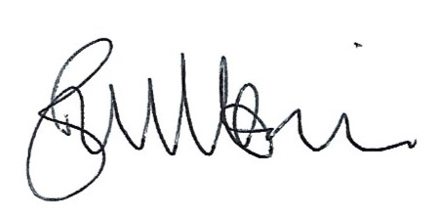
SIGNED: ……………………………….
Bernard Morris, Clerk to Woore Parish Council

