WOORE PARISH COUNCIL
VACANCY FOR COUNCILLOR
There is one casual vacancy on the above Council following the resignation of Councillor Julia Mitchell.
Following the notice dated 21st December 2018, a by-election to fill the vacancy has not been claimed. It is now the intention of the Parish Council to fill the vacancy by co-option.
Parishioners wishing to be considered for the vacancy should please obtain a nomination form. Nomination forms can be obtained from Sarah Pimlott, the Parish Clerk (email: clerk@wooreparishcouncil.org or telephone 01270 624359) or can be downloaded from the Woore Parish Council website: www.wooreparishcouncil.org
The closing date for submitting nominations to the Parish Clerk is noon on Wednesday 6th February 2019.
If you require any further information or details, please contact the Parish Clerk (contact details above).
Dated 18th January 2019
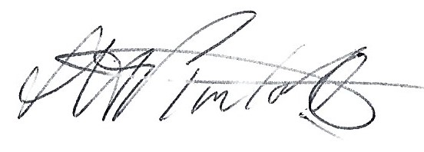
SIGNED: ……………………………….
Sarah Pimlott, Clerk to Woore Parish Council

