WOORE PARISH COUNCIL
NOTICE UNDER LOCAL GOVERNMENT ACT 1972 (SECTION 87(2)) VACANCY FOR A COUNCILLOR

PUBLIC NOTICE IS HEREBY GIVEN
that a casual vacancy has occurred in the office of Councillor for the Parish of Woore following the resignation on 14th December 2018 of Councillor Julia Mitchell.
Rule 5(2) of the Local Elections (Parishes and Communities) (England and Wales) Rules 2006 now applies.
The rule allows TEN ELECTORS for the parish in which the casual vacancy has arisen to request the Returning Officer to hold an election to fill the vacancy.* That request must be made within FOURTEEN DAYS, calculated in accordance with the rules, of the date of this notice. The fourteen-day period ends on 16TH JANUARY 2019.
What if a request to hold an election is not received during the permitted time?
Rule 5(5) of the above Rules will apply. The Parish Council must, as soon as practicable after the expiry of the fourteen-day period, co-opt a person to fill the vacancy.
The Returning Officer’s address is:
Electoral Services, Shropshire Council, The Shirehall, Abbey Foregate, Shrewsbury, Shropshire SY2 6ND.
The telephone number for further guidance is 0345 678 9015.
This notice is dated the twenty first day of December 2018.
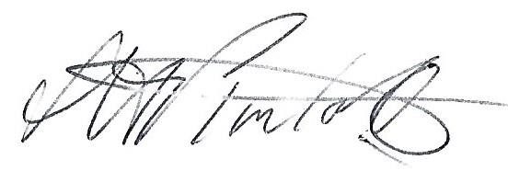
………………………………………
Ms. S.H. Pimlott, Clerk to Woore Parish Council.
Address: North Barn, Coole Lane, Nantwich, Cheshire CW5 8AB.
Tel: 01270 624359. Email: clerk @wooreparishcouncil.org
*There is no form of words for this request, which might simply be a letter headed with such words as “We the undersigned, being electors for the Parish of Woore, call for an election to fill the vacancy arising from the resignation of Councillor Julia Mitchell.” A template entitled “Request for an Election” is available to download from Shropshire Council’s website – www.shropshire.gov.uk – under “Current Council Vacancies”. It is helpful if the ten signatures are accompanied by printed names and addresses.

